- 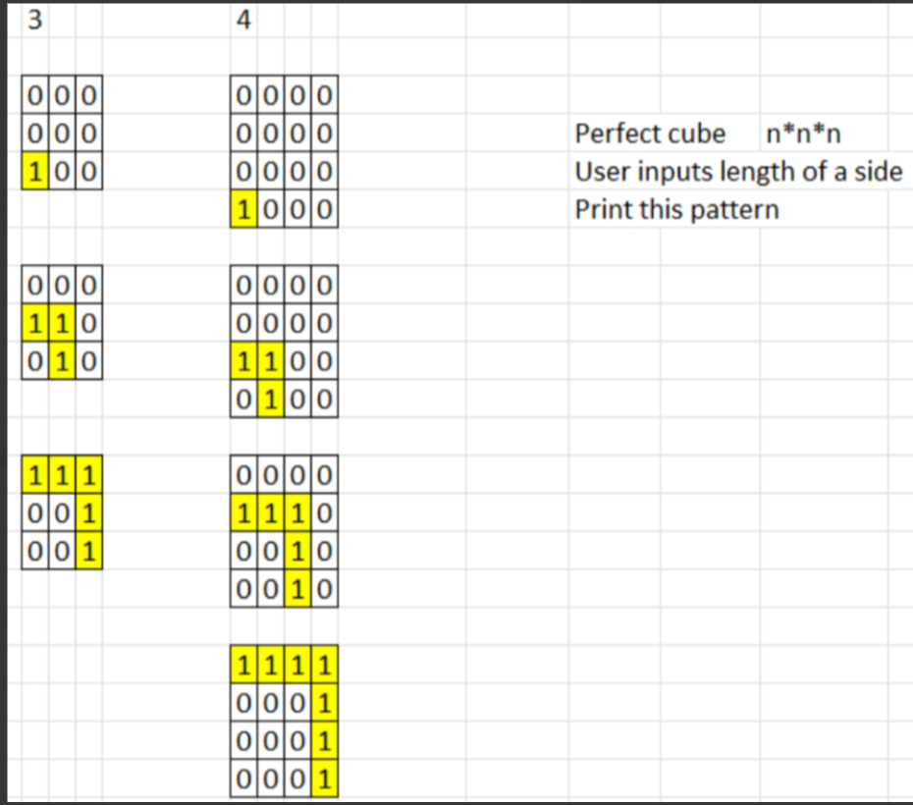
- how to create combinations for a list =[a,b,c,d ] without using any library 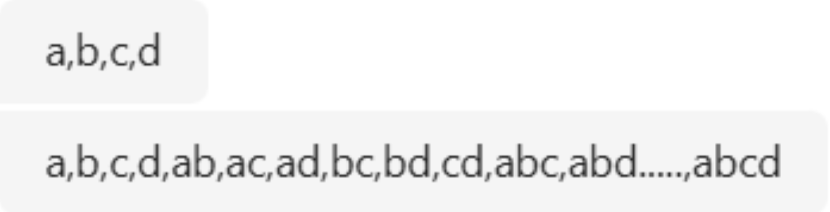
- data engineer questions:
- how is parquet different from CSV files
- medallion architecture
- if you have this list of grocery shopping where first element is transaction number how do you find out patterns of which of the items are bought together
list = [[1,'bread','butter'],[2,'bread','milk'],[3,'bread','butter','jam'],[4,'bread','butter','jam']]
for example in this list how will you find bread butter is bought together
how do you find that without using any libraries
- what is map-reduce in Hadoop
- how does pyspark work
- what is rag
- how does chat/completion model work
for example your phones keyboard- how does it suggest you words
- what are vector databases
- what are vectors and how are they stored in the vector databases
- vector embedding
- How auto suggestion works like how the next word or token generated

